**Section Three: Comprehension 20% (36 Marks)**

**Question 1 (18 marks)**

**The Physics of Skipping Stones**

(Adapted from: The Mystery of the Skipping Stone, Physics World Vol 19 No 2 February 2006 Bocquet L and Clanet C)

|  |  |
| --- | --- |
| http://discovermagazine.com/~/media/import/images/5/1/4/featscience1 | Champion stone skipper Kurt Steiner has been stopped going through customs with bags full of rocks and always carries a five-sided stone in his pocket. |

In 2002 an American named Kurt Steiner set a new world record when he threw a

stone across a river in Pennsylvania and made it bounce 40 times. Most people will

not have been quite as successful as Steiner, but many will be familiar with the

principle of stone skipping: to throw a flattish stone across the surface of a body of

water so that it bounces as many times as possible.

It has been shown that the formula that relates collision time (of a stone with the water

surface) and velocity for a stone is given by;

$T= \left(\frac{MR}{ρS}\right)\left(\frac{1}{v}\right)$

where: $T$ is the collision time (s) $M$ is the mass of the stone (kg) $R$ is the radius of the stone (m) $ρ$ is the density of water (kg m-3)

is the cross-sectional area of the stone (m2)

is the velocity of the stone (m s-1)

The data below pertains to a stone of dimensions:

$M$ = 15 g; $R$ = 3 cm; = 3.6 x 10-6 m2

**Question 1 (continued)**

|  |  |  |
| --- | --- | --- |
| **Collision Time (ms)** | Velocity (m s-1) |  |
| 56 | 2 |  |
| 37 | 3 |  |
| 22 | 5 |  |
| 16 | 7 |  |
| 12 | 9 |  |
| 10 | 11 |  |
| 7.5 | 15 |  |

1. Given the formula above, what should you plot to obtain a linear graph? [2]
2. Use the third column in the table to process the given data to allow you to plot a linear graph. Label the column with appropriate units. [3]

1. Plot the graph on the graph paper provided. [5]
2. Determine the gradient of your line. [2]

1. Use the gradient of your curve to determine the density of water. [2]



**Question 1 (continued)**

Experiments have also shown that a bouncing stone must spin with a certain minimum rotational velocity if it is to be stable i.e. if the angle between the plane of the stone and the water surface is to remain constant. To remain stable, a stone typically needs to rotate at least once during its collision time. If this rotation does not take place, the stone’s collision becomes quite complex and a second bounce becomes much less likely.

1. If a stone is to rotate at least once during its collision time, what must the minimum spin velocity be equal to? [1]

(Hint – this does not require a numerical answer)

1. People who are good at stone skipping, intuitively rotate stones with a flick from the finger. Why do they do this? [1]

Researchers found that, surprisingly, the stone does not slow down during the skipping process, but rather the stone’s trajectory ‘flattens’ with time. This is because the angle with which the stone moves relative to the water dictates that the stone displaces more water when it moves down than rises. This results in a smaller transfer of momentum in the latter stage of each skip and therefore in reduced lift. When the stone no longer has enough energy to jump, it simply surfs over the water before finally sinking.

The number of skips is also determined by the type of stone used and the angle at which it is thrown. And as all stone skippers know, the flatter the stone, the better!

1. The passage describes the stone’s trajectory as ‘flattening’. Explain what this means with regards to changes in the horizontal and vertical components of the velocity.

[1]

i) Why would there be reduced lift in the latter stages of the motion? [1]

**Question 2 (18 marks)**

**Gravitational Red Shift**

Red shift is often explained as being similar to the Doppler Effect. An example of the Doppler Effect is the alteration in sound that occurs when a car passes. As the car approaches the observer the sound of the engine is higher than after the car has passed.

Cosmological Red shift and Blue shift occurs in a similar way. Instead of sound being emitted by a car moving towards or away from you however, it is light being emitted by a star as it moves towards or away from the earth. If the star is moving towards the earth all of the frequencies emitted will be slightly increased. This is called Blue shift. Conversely if the star is moving away from the earth all of the frequencies emitted will be slightly lowered. This is called Red shift.

The formula for cosmological red-shift is

fL = ( ) fS

Where

|  |  |  |
| --- | --- | --- |
| **Symbol** | **Definition** | **Units** |
| fL | Frequency observed by the person on earth. | Hz |
| fS | Frequency of the source | Hz |
| c | Speed of light in a vacuum (3 x 108 m s-1) | m s-1 |
| v | Speed of the object producing the electromagnetic radiation (light)  v = away from earth 🡪 v = positive.  v = towards the earth 🡪 v = negative. | m s-1 |

Instead of considering blue and red shift purely as a frequency effect, a better understanding can be found by consider the energy of the situation. When photons are blue shifted they have a higher frequency. This means they have more energy. Red shift reduces the energy that a photon has. This can be considered analogous to kinetic energy.

Let’s do 3 thought experiments …

i) A stationary person throws a 100g ball forwards at 10 m s-1.

ii) A person riding a bike forwards at 5 m s-1 throws a 100g ball forwards at 10 m s-1.

iii) A person riding a bike backwards at 5 m s-1 throws a 100g ball forwards at

10 m s-1.

The velocities of the each ball are 10 m s-1, 15 m s-1 and 5 m s-1 respectively.

The kinetic energies of each ball are 5 J, 11.25J and 1.25J respectively.

**Question 2 (continued)**

In the above thought experiment we see that the velocity of the bike effected the kinetic energy of the ball. When the movement of the bike was in the same direction as the ball the kinetic energy increased and when they were in opposite directions it decreased.

Light from a star is actually a stream of photons being thrown from the star out into space. Photons have different properties to a ball however and so the formula for calculating the energy of a photon will be different from the energy of a ball. Both of these energies (ball or photon) can be regarded as kinetic energies.

So to summarise the story so far we see that the kinetic energies of particles can be modified by the speed of the object that throws them.

Kinetic energies of objects can also be modified by gravity. When a ball is thrown up into the air, the kinetic energy of the ball drops as its speed decreases. The potential energy of the ball increases as the distance of separation between the centre of the earth and the centre of the ball increases.

It is not surprising to discover therefore that gravity can also alter the energy of a photon. Gravity cannot alter the speed at which light / photons travel. This speed is constant regardless of the situation. If we cannot alter speed we will have to alter another variable that is related to photon energy. We will alter frequency.

When photons are emitted by stars they have to escape the gravitational field of the star. This means that as the photon travels outwards it will lose “kinetic” energy and its frequency will be progressively red shifted. The stronger the gravitational field of the star, the more red shifted the photons produced by the star. This is called Gravitational Red Shift.

The formula for gravitational red shift is

fL = fS

Where

|  |  |  |
| --- | --- | --- |
| **Symbol** | **Definition** | **Units** |
| fL | Frequency of the photon observed by the person outside stars gravitational field. | Hz |
| fS | Frequency of the photon observed in the stars gravitational field | Hz |
| c | Speed of light in a vacuum (3 x 108 m s-1) | m s-1 |
| G | The gravitational constant 6.67 x 10-11 | N m2 kg-2 |
| M | Mass of the star. | kg |
| R | Distance from the centre of the star. | m |

**Question 2 (continued)**

Let’s suppose the “kinetic” energy required to escape a particular star’s gravitational field is larger than the energy of the most energetic photon. Based on this logic the photon will not escape. In this situation the star will be called a black hole.

a) State TWO similarities and TWO differences between the gravitational red shift of a photon and the ionisation energy of an electron and atom. [4]

|  |  |  |
| --- | --- | --- |
|  | **Gravitational Red Shift** | **Ionisation Energy** |
| **Similarities** |  | |
|  |  | |
| **Differences** |  |  |
|  |  |  |

b) Based on cosmological red shift what will be the frequency of an originally blue photon of wavelength 500 nm that that has been emitted from an electric torch moving away from an astronaut in empty space at a speed of 20 000 km s-1?

[3]

**Question 2 (continued)**

c) To which part of the electromagnetic spectrum does the photon received by the

astronaut belong? State the colour if it is within the visible spectrum using the chart

below. [1]

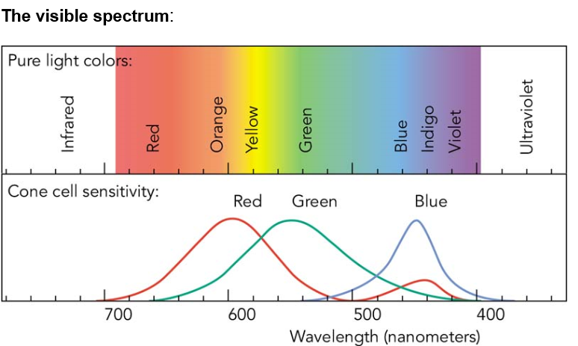

d) The astronaut returns to earth and is looking through a telescope at the torch which is still flying away one hour later. Explain **two** ways in which the photons from the torch will now look different from your answer to part b).

[2]

**Question 2 (continued)**

e) Using the gravitational red shift formula, state the new frequency of a 9.00 x 1015 Hz photon originating at the surface of our sun. The new frequency is received / measured in empty space outside the sun’s gravitational field. [4]

f) Would Edwin Hubble need to take gravitational red shift into account in formulating his theory of an expanding universe? Explain why or why not. [2]

g) A satellite orbiting the earth is set to receive signals at a frequency of 3.00 x 106 Hz. Should the signal be sent from the transmitter at the surface of the earth at a frequency above, equal to or below 3 x 106 Hz taking into account gravitational red shift? Do not calculate your answer. [2]

END OF EXAMINATION